|  |
| --- |
| [Type the company name] |
| User Manual |
| IITI SCHEDULER |
|  |
|  |
|  |

|  |
| --- |
|  |

# Table of Contents

# Introduction

“IITI Scheduler” is a web-based application which aids in easy and fast production of Time Tables. With an easy drag-and-drop interface and intuitive tabular display with conflict display, it aims to provide the user with a conflict free timetable with minimal effort.

# Landing Page

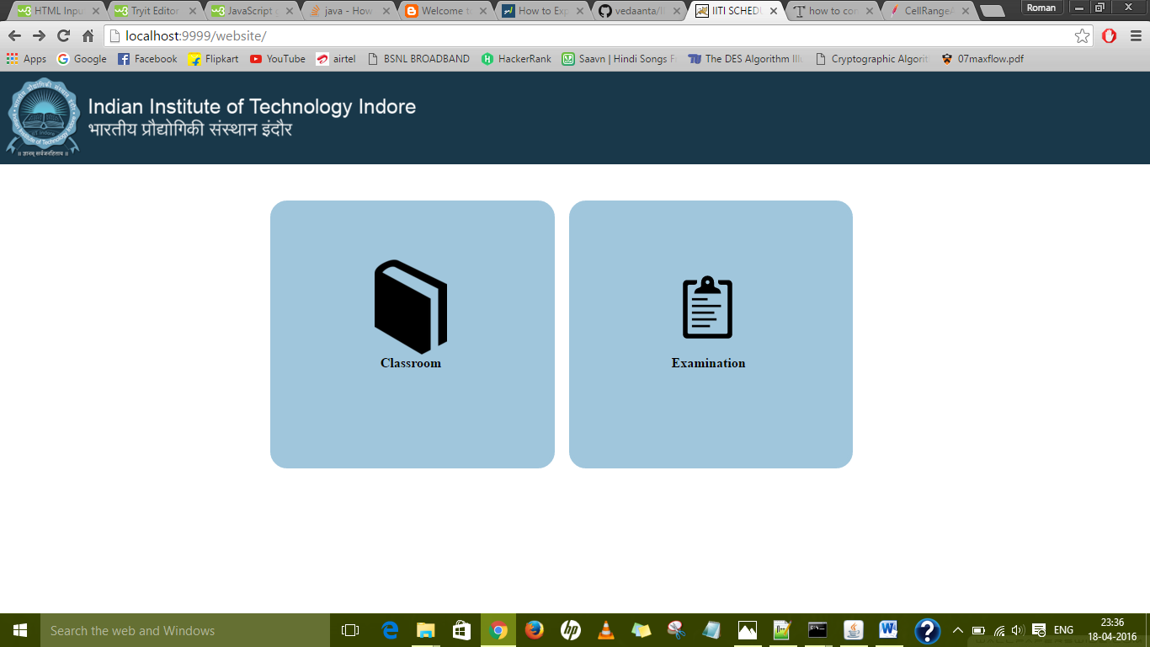

On logging in the IITI admin page, the user is greeted with a simplistic minimal user interface, consisting of two buttons, namely “Classroom” and “Examination”.

## Classroom Timetable Development

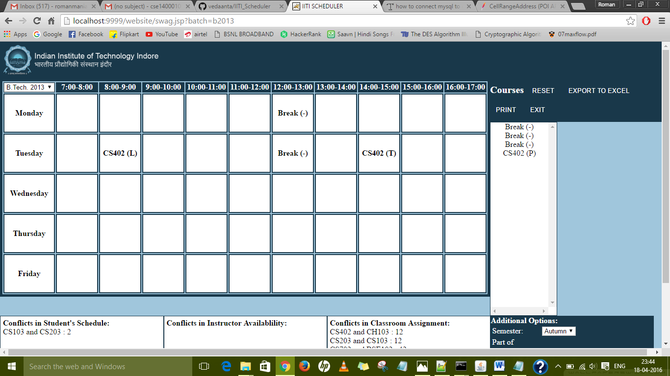

On Clicking the “Classroom” button, the system moves to the TimeTable Development View, where a grid is displayed depicting the stored Subjects in particular Time Slots.

1. If no subjects are stored previously in the database, an empty grid will be displayed.
2. In the upper-right corner of the grid, a “Batch” drop-down is available, which avails the user to select a particular batch for the development of TimeTable.
3. To change the time periods for the classes, select any one of the time intervals, thus opening a popup asking the user for the starting time. Clicking Submit updates the time.

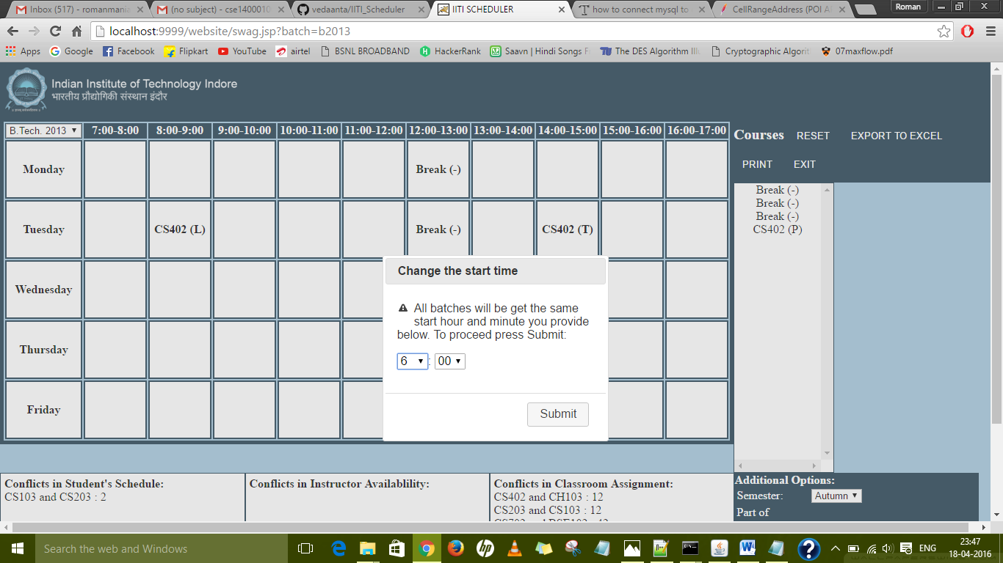

1. To assign a particular Course to a Time Slot, just drag the Course from the Course List to the respective Time Slot. The selected Slot will be highlighted with a “Red” colour.

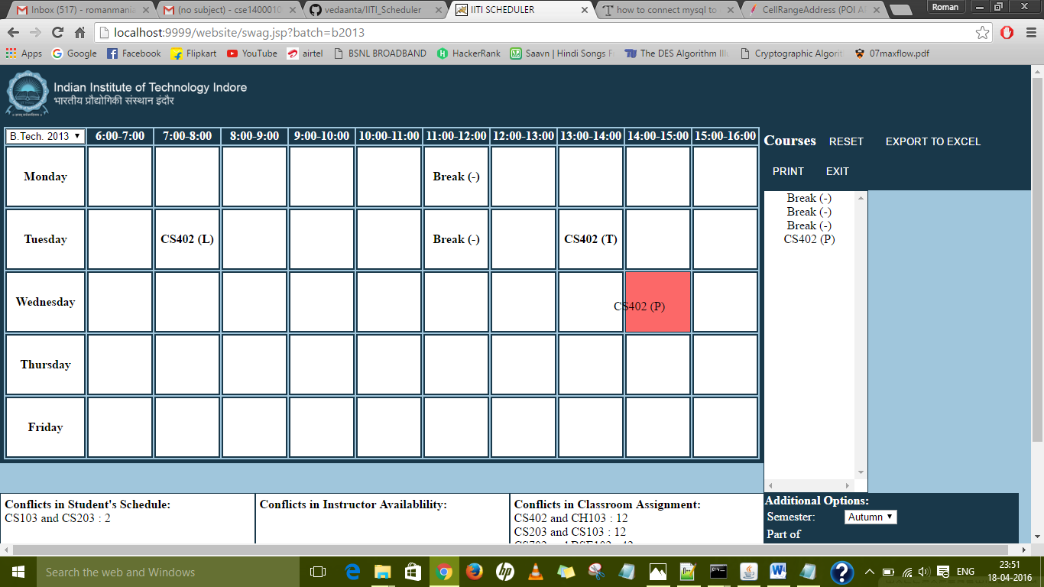

1. On dropping the Course, if the Course is not a “Break”, a popup will ask the user to submit the respective Classroom for the course.

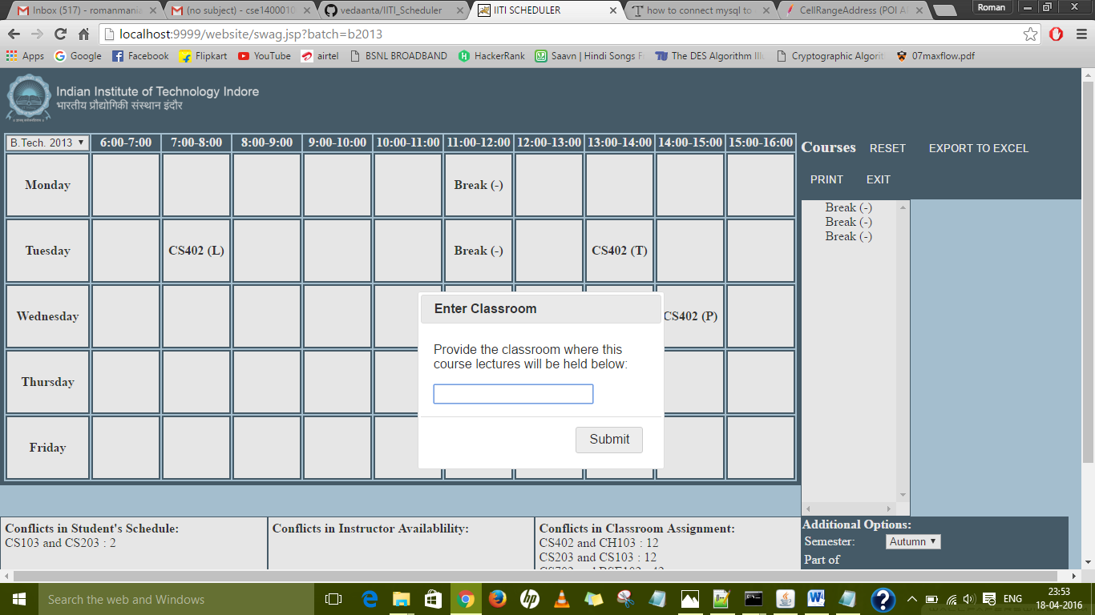

1. The Conflicts for the current Time Table setup will be displayed in the text areas below the grid.

